Vowel Prothesis before /r/ revisited: Acoustic Correlates

0. Introduction
- Hall (2011) identifies the phonological process of vowel prothesis in Walliser German, whereby the vowel /a/ is epenthesized before /r/ at the beginning of a word provided that the word is not proceeded by an unstressed vowel.
- Herein, I would like to revisit this issue of the phonological behavior of vowel prothesis before /r/, considering the phonetics and typology of vowel prothesis before /r/ along the way.

1. Background: What is a rhotic?

- Typology of Rhotics (cf. Wiese 2011)
 | Alveolar | Retroflex | Uvular
Trill | r |  | ʀ
Tap or Flap | ɾ | ɽ
Fricative |  |  | ʁ
Approximant | ɹ | ɻ | (ʁ̞)
Lateral Flap | ɺ

- Ladefoged and Maddieson (1996:215), for instance, take the position that “the terms rhotic and r-sound are largely based on the fact that these sounds tend to be written with a particular character in orthographic systems derived from the Greco-Roman tradition, namely the letter ‘r’ or its Greek counterpart rho”.
- Acoustic definition: Lowered third formant?
- However, Hausa (retroflex approximant) has a higher third formant; Czech, with its famous fricative-trill r, was found to be around 3000Hz; Uvular r in Swedish, French and German was likewise found to be around 2500Hz; Arrernte’s retroflex approximant has a high third formant with around 2200Hz.
- But, what about phonotactic distribution?

- Initial Stop + Sonorant Clusters of German (Wiese 2011)
 | /ʀ/ | /l/ | /n/ | /m/
/p/ | Preis ‘price’ | Platz ‘place’ | Pneu ‘tire’ | -------
/b/ | braun ‘brown’ | blau ‘blue’ | ------- | -------
/t/ | Traum ‘dream’ | ------- | ------- | Tmesis
/d/ | drei ‘three’ | ------- | ------- | -------
/k/ | Kreis ‘circle’ | klug ‘clever’ | Knie ‘knee’ | Khmer ‘Proper Name’
/g/ | grau ‘grey’ | Glaube ‘belief’ | Gnade ‘mercy’ | Gmünd ‘City name’

- Wiese (2011) argues: “rhotics are defined as those sounds which bear a sonority value between that of vowels (including glides) and the next lower sonority class, is supported by the fact that the freedom of rhotics to combine with a preceding stop is independent of the particular type of the r-phoneme present in the respective variety of German – place features as well as manner features of the rhotic phoneme are always irrelevant”.
- Another idea: Hall (p.c.) has suggested that rhotics can be classified as those sounds that are featural [+son, +cons, +cont].

2. Typology of Vowel Prothesis before /r/

- Languages attested with Vowel Prothesis before /r/
 | Language | Source
 | Walliser German | Hall (2011), Wipf (1910)
 | Basque | Hualde (1991:12), McColl-Millar (2007:82)
 | Sestu Dialect of Sardinian | Smith (2003), Bolognesi (1988)
 | Iglesias Dialect of Sardinian
 | Armenian | Vennemann (1986), Picard (1989)

A. Visper Walliser German

- Word-initial vowel prothesis (cf. Hall 2011:948)
Standard German | Walliser German | Gloss
Rad | [a-rad] | ‘wheel’
schnarchen | [a-rǖtsu] | ‘to snore’
reif | [a-ripf] | ‘to ripe’
Ruhe | [a-reppo] | ‘calmness’
ernten | [a-röibu] | ‘to harvest’

- Vowel Prothesis in its various contexts (Wipf 1910:106)
 | Context | Example | Standard German | Gloss
a. | After a pause | [a-rad] | Rad | ‘wheel’
b. | After final consonant | [ds a-rōtta] | das Rote | ‘the red one’
c. | After a stressed vowel | [dǖ müošt ṓi a-redu] | du musst auch reden | ‘you also have to speak’
d. | After an unstressed vowel | d štirna Ø-rimpfu | die Stirn rümpfen | ‘to furrow one’s brow’

- The rhotic articulation in this dialect is a “stark gerolltes alveolares r” (Wipf 1910:14).

B. Campidanian Sardinian

- Campidanian vowel epenthesis before word-initial /r/ (Modified from Bolognesi (1998:42)
Latin | Italian | Campidanian | Gloss
rosa | rosa | arːɔza | ‘rose’
rivus |  | arːiu | ‘river/creek’
rana | rana | arːana | ‘frog’
rota | ruota | arːɔða | ‘wheel’
 | ricco | arːikːu | ‘rich’
 | radio | arːaðiu | ‘radio’

- This process has been described by Virdis (1978:58) as: “Initial /r/ remains unaltered [with respect to Latin], extremely often, however, but we could even say generally and constantly, a prosthetic vowel is inserted and the consonant [/r/] is strengthened. […] The vowel is [a] in most of the Campidanian area.”
- How is /r/ articulated in this dialect?

C. Basque vowel prothesis
- Basque, like other languages of the Iberian peninsula, has two rhotics: /r/ and /ɾ/

- Spanish Loanwords with word-initial [r] adapted into Basque (cf. Hualde 1991)
 | Spanish | Basque | Gloss
a. | república | errepublika | ‘republic’
 | respuesta | errespuesta | ‘answer’
 | romería | erromeria | ‘pilgramage’
 | respeto | errespeto | ‘respect’
b. | ratón | arratoi | ‘mouse’ (Sp), ‘rat’ (Ba)
 | ropa | arropa | ‘clothes’
 | raza | arraza | ‘race’

- Basque distribution of [r] and [ɾ] as compared to Spanish: A Summary
 | Spanish |  | Basque
 | [r] | [ɾ] | [r] | [ɾ]
#____ V | √ | × | × | ×
C____ V | × | √ | √ | ×
V____ V | √ | √ | √ | √
V____ C | × | √ | √ | ×
V____ # | × | √ | √ | ×

D. Gascon Vowel Prothesis
- Gascon, a Romance variety spoken in Southwestern France, near the border with Spain, also exhibits a process of vowel prothesis conditioned by an etymologically word-initial *r.
- However, the sources agree on one important fact: that <rr> is articulated as a tongue tip trilled [r] (cf. Roques 1977:55, Kelly 1973:32).
- The Dictionnaire Français-Occitan (1998:16) considers vowel prothesis before /r/ as a general phenomenon of Gascon and typically encodes vowel prothesis before /r/ in its orthography as <arr…>, provided that the form is general throughout the Gascon speaking territory. If it is more typical of the mountainous regions, but less commonly found outside of that area, then it is encoded as <(ar)r…>

- Gascon words prosthetic vowel before /r/ (cf. Dicionnaire Français Occitan, page as indicated)
 | Gascon | French | English | Page
a. | arremóler | rabâcher | ‘to harp on about’ | p. 116
 | arrat | rat | ‘rat’ | p. 117
 | arregaudir-se | se réjouir | ‘to be pleased’ | p. 119
b. | (ar)respectar | respecter | ‘to respect’ | p. 121
 | (ar)religar | relier | ‘to link’ | p. 120
 | (ar)retardar | retarder | ‘to delay’ | p. 122
c. | rabin | rabbin | ‘rabi’ | p. 116
 | raqueta | raquette | ‘racket’ | p. 117
 | realisme | réalisme | ‘realism’ | p. 118

- I have tabulated the results here of all words that begin with initial /r/ in French and either have <arr…>, <(ar)r…> or <r…> in Gascon. These data are presented in the table below.

- Frequency of Gascon Vowel Prothesis
Category | Number of examples | Percent
a. <arr…> | 34 | 8.8%
b. <(ar)r…> | 310 | 80.5%
c. <r…> | 41 | 10.6%
Total | 385

- Thus, it can be seen that the great majority of Gascon cognates of French words with initial /r/ exhibit variable vowel epenthesis. Few words exhibit initial /r/ across the board and still fewer exhibit an epenthetic vowel across the board.

E. Armenian Vowel Prothesis: A challenging example
- Armenian, like Basque, also has two types of rhotic, namely /r/ and /ɾ/.

- Type 1: Canonical Vowel Prothesis before /r/ in Armenian
Historical Form | Armenian | Orthography | Gloss
*regwos | erek |  | ‘evening’
*rewis | arew |  | ‘sun’
*rug- | orcam |  | ‘I vomit’
*treyes | erekʰ |  | ‘three’

- Type 2: Vowel Prothesis before /r/, derived from a stop
Historical Form | Armenian | Orthography | Gloss
*dwṓ | erku |  | ‘two’
*dwi | erkiwł |  | ‘fear’
*dwāros | erkar |  | ‘long’

- Type 3: Vowel Prothesis
Historical Form | Armenian | Orthography | Gloss
*srudis | aru |  | ‘canal’
*dráku (~ *dakru) | artawsr |  | ‘tear’
*gwráwon | erkan |  | ‘millstone’
*bʰrḗwr̩ | ałbewr |  | ‘spring-well’
*bʰrā́ter | ełbayr |  | ‘brother’

- My proposal on the different sources of #er__ in Armenian:
- Original Laryngeal: erek ‘evening’ < *h₁reg^{w}os (cf. Gk. érebos ‘darkness of the underworld’
- *dw-Sound change
- Metathesis e.g. ełbayr ‘brother’ < PIE bhrātēr; ałbewr ‘spring-well’ < *bʰrḗwr̩
- With deletion of initial *s e.g. aru ‘canal’ < *srudis
- Syllabic liquid (?): arbi ‘I drank’ < *sr̥b^{h}- (with loss of *s, maybe a subtype of 4?)

- Conclusion: Armenian vowel prothesis is complicated and it is not obvious how it fits into the typology of vowel prothesis before rhotics.
- However, Armenian can still be considered within the research inquiry argued for herein to the extant that Armenian places a ban on trills in absolute word-initial position.

3. Acoustics of Vowel Prothesis before /r/
A. Vowel Prothesis before /r/
- As described by Ladefoged and Maddieson (1996:217), trilling is in many ways a similar process to voicing. In essence, there is no active muscle control of each vibration cycle involved in either. Instead, both involve placing two surfaces closely next to one another and allowing air to pass through creating a series of vibrations.
- Crucially, there is one property about trills that has been known to phoneticians for quite a long time. Consider the following quote from Ladefoged and Maddieson (1996:219): “First, the contacts are preceded by a short approximant or vowel-like sound of about 50 ms duration. Secondly, after the contacts there is another approximant interval, lasting over 50ms…the approximant phases flanking this trill indicate that the tongue was not consistently held close enough to the upper surface of the mouth for trilling to be sustained. Approximant phases at the end of trills occurred on some occasions in all the languages with trills studied by Lindau (1985)”.

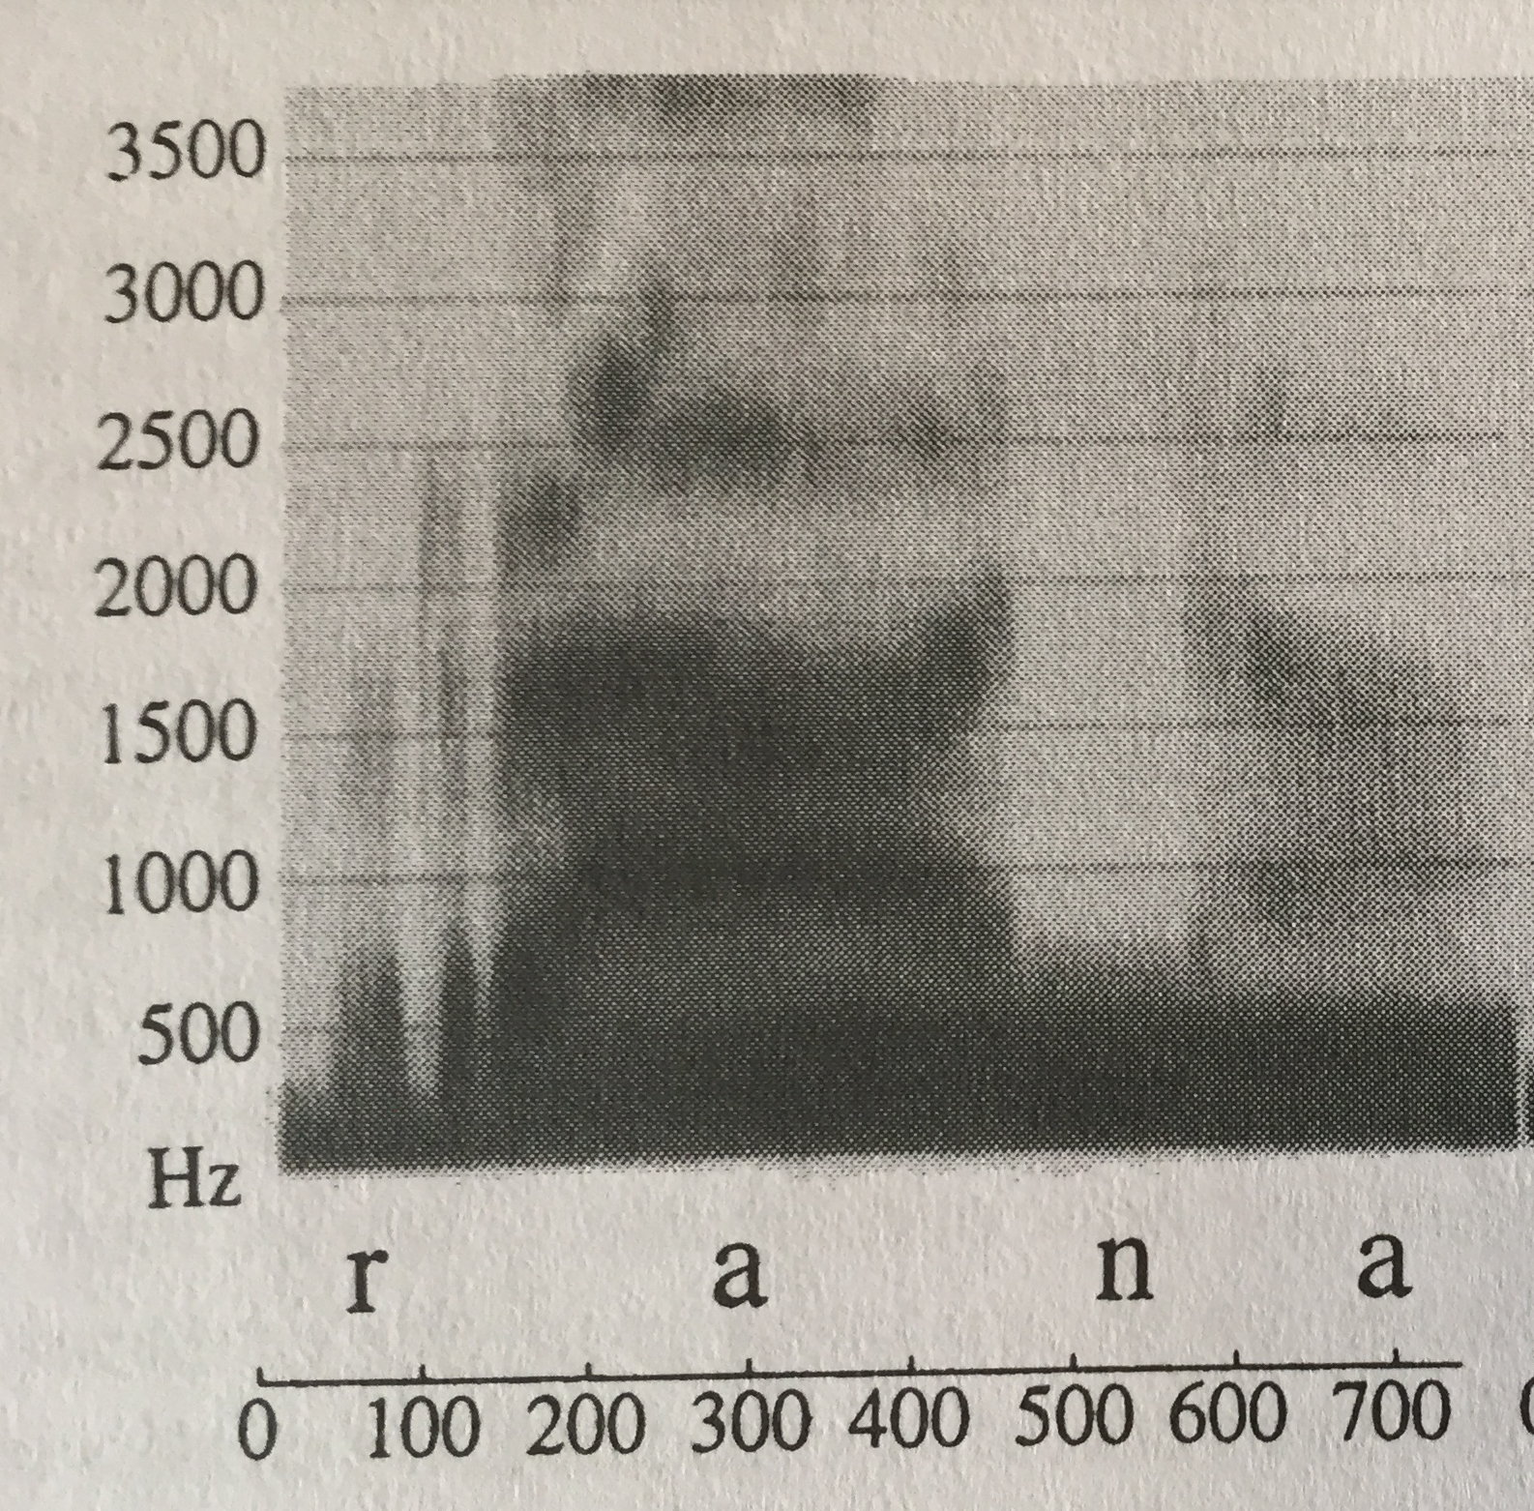
Figure 1. Word-production of Italian word-initial /r/ see Ladefoged and Maddieson (1996:220).

- Ohalian language change: Ohala (1993 and elsewhere) has argued that language change can be explained nicely by the idea that certain properties of the phonetic string might be “misperceived” by the listener as being part of the speaker’s “intended phonetic string” and not simply as a byproduct of natural tendencies of the human vocal tract.

- Listener correctly perceiving speaker’s intended phonetic string (adapted from Ohala 1993:157)
Speaker’s Intended Phonetic String A B

What is produced phonetically: a₁ a₂ B

Listener parse: A B

- Listener incorrectly perceiving speaker’s intended phonetic string (adapted from Ohala 1993:157)
Speaker’s Intended Phonetic String A B

What is produced phonetically a₁ a₂ B

Listener parse: A B C

- Schematic for Vowel Prothesis before /r/
Speaker’s Intended Phonetic String #r V

What is produced phonetically #v r V

Listener parse: #V r V

B. Possibility of vowel prothesis before /ʀ/?
- It appears that this kind of epenthesis is much more sparsely attested.
- Reasons: Uvular /ʀ/ is generally sparsely attested
- In most languages with uvular trills it is also possible for speakers to use a different type of uvular articulation e.g. a fricative /ʁ/ or an approximant /ʁ̞/.
- So, it could be said these languages have a repair strategy for /ʀ/ in initial position that is not merely the process of epenthesizing a vocalized period before the initial trilled /r/.

4. Phonology Theory section

- Word-Edge Hierarchy Constraints (cf. Hall 2011:958)
*_{ω}[Glides >> *_{ω}[Rhotics >> *_{ω}[Laterals >> *_{ω}[Nasal >> *_{ω}[Obstruent

- Markedness and Faithfulness constraints (Hall 2011:958):
a. Onset: A syllable must have an onset
b. Dep-V: Don’t insert a vowel
c. Dep-C: Don’t insert a consonant
d. Max-V: Don’t delete a vowel
e. Max-C: Don’t delete a consonant
f. Ident: Don’t change the features of an input sound

- Epenthesis before /r/ (cf. Hall 2011:958, to be revised below)
/rad/ |  | *_{ω}[Rhotics | Onset | Dep-V | * _{ω}[Laterals
a. | _{ω}[rad] | *!
b. ☞ | _{ω}[arad] |  | * | *

- No epenthesis before /l/ (to be revised)
/lad/ |  | *_{ω}[Rhotics | Onset | Dep-V | * _{ω}[Laterals
a. ☞ | _{ω}[lad] |  |  |  | *
b. | _{ω}[alad] |  | *! | *

- As I have shown in sections 2-3, languages with #rV #VrV have an alveolar trill, [r], as their rhotic consonant and that this vocalic epenthesis follows from natural phonetic tendencies involving the difficulties of producing a trill in word-initial position.
- Therefore, in the remainder of this section, I will dispense with the constraints in (16) and instead will use the constraint in (20) below.

- *_{ω}[Trills: Trills are banned from prosodic-word initial position.

- Epenthesis before /r/ (Walliser German, Campidanian Sardinian, Basque, Gascon)
/rad/ |  | *_{ω}[Trill | Max-C | Dep-C | Ident | Onset | Dep-V
a. | _{ω}[rad] | *!
b. ☞ | _{ω}[arad] |  |  |  |  | * | *
c. | _{ω}[lad] |  |  |  | *!
d. | _{ω}[ad] |  | *! |  |  | *
e. | _{ω}[trad] |  |  | *!

- Segmental change of initial /ʀ/ (Standard German)
/ʀad/ |  | *_{ω}[Trill | Max-C | Dep-C | Dep-V | Onset | Ident
a. | _{ω}[ʀad] | *!
b. | _{ω}[aʀad] |  |  |  | *! | *
c. ☞ | _{ω}[ʁ̞ad] |  |  |  |  |  | *
d. | _{ω}[ad] |  | *! |  |  | *
e. | _{ω}[tʀad] |  |  | *!

5. Conclusion and Residual Issues
- Falsifiable Prediction: A language that attests a change of #rV- #VrV- will necessarily have a trilled r.
- Furthermore, it seems likely that that rhotic would be [r] and not [ʀ]
- Herein I have not considered the process of vowel prothesis before /ʙ/. Neither Ladefoged and Maddieson (1996) nor Wiese (2003, 2011) consider this sound to be a rhotic, but I leave this question open for further research.
- As Hall (2011:947) discusses the Sestu dialect of Campidanian (in contrast to the Iglesias dialect) actually attests vowel prothesis before /r/ and /j/. My account would see this development as two separate changes, since /j/ does not have the same articulatory difficulties at the beginning of a word.
- What is the epenthetic vowel? The data in Basque and historical Sardinian sometimes seem to reflect a vowel harmony-like conditioning of the epenthetic vowel.
- Interestingly, the varieties with #rV #VrV are mostly confined to a few non-prestige varieties of Western European languages, which might suggest that orthography plays a role in this process. Furthermore, these varieties are found in highly isolated areas such as the Pyrenees, Alps or Sardinia.
- East Slavic so-called polnoglasie viz. Russian, Ukrainian город vs. Polish gród, Czech hrad (< CSL *gordos, OCS градъ) may represent a similar phenomenon, though the data there is less clear.

References

Bolognesi, R. (1998). The phonology of Campidanian Sardinian : a unitary account of a self-organizing structure. The Hague: Holland Academic Graphics.

Delattre, P.C. & D.C. Freeman (1968). A Dialect Study of American r’s by X-Ray Motion Picture. Linguistics 44: 29-68.

Hall, T. A. (2011). Vowel prothesis in Walliser German. Linguistics 49.5: 945–976.

Hualde, J. Ignacio. (1991). Basque phonology. London: Routledge.

Kelly, R. Cardaillac. (1973). A descriptive analysis of Gascon. The Hague: Mouton.

Kohler, K. J. (1995). Einführung in die Phonetik des Deutschen. 2., neubearb. Aufl. Berlin: E. Schmidt.

Ladefoged, P. & I. Maddieson (1996). The Sounds of the World’s Languages. Malden, MA: Blackwell Publishing.

Lindau, M. (1985). “The Story of r.” In Phonetic Linguistics, ed. by V.A. Fromkin. Orlando, FL: Academic Press, 157-68.

Maddieson, I. (2013). Uvular Consonants. In: Dryer, Matthew S. & Haspelmath, Martin (eds.) The World Atlas of Language Structures Online. Leipzig: Max Planck Institute for Evolutionary Anthropology. (Available online at http://wals.info/chapter/6, Accessed on 2017-04-26.)

Mielke, J. (2005). Ambivalence and Ambiguity of Laterals and Nasals. Phonology 22: 169-203.

McColl Millar, R. (2007). Trask’s Historical Linguistics. Second edition. London: Holder Arnold.

Ohala, J. J. (1993). Sound change as nature's speech perception experiment. Speech Communication. 13: 155-161.

Picard, M. (1989). A Reanalysis of Armenian Prothesis and Metathesis. Folia Linguistica Historica 10: 61-70.

Rogers, D. & L. d’Arcangeli (2004). Italian. Journal of the International Phonetic Association 34.1: 117-121.

Roques, G. (1977). Grammaire gasconne : dialecte de l'Agenais : glossaire gascon-languedocien. Genève: Slatkine Reprints.

Shelton, M. (2013). Spanish Rhotics: More Evidence of Gradience in the System. Hispania, 96(1), 135-152. Retrieved from http://www.jstor.org.proxyiub.uits.iu.edu/stable/23608459

Smith, J.L. (2003). Onset Sonority Constraints and Subsyllabic Structure. Rutgers Optimality Archives [ROA] 608-0703.

Vennemann, T. (1986). Syllable-Based Sound Changes in Early Armenian. Annual of Armenian Linguistics 7, 27-43.

Virdis, M. (1978). “Fonetica Storica del Dialetto Campidanese.” Edizioni della Torre, Cagliari.

Wiese, R. (2003). The Unity and Variation of (german) /r/. Zeitschrift Für Dialektologie Und Linguistik, 70.1: 25-43. Retrieved from http://www.jstor.org.proxyiub.uits.iu.edu/stable/40504887

Wiese, R. (2011). The Representation of Rhotics. In: Marc van Oostendorp, Colin Ewen Elizabeth Hume and Keren Rice (eds.) The Blackwell Companion to Phonology. Malden, MA & Oxford: Wiley-Blackwell, 711-729.

Wipf, E. (1910). Die Mundart von Visperterminen im Wallis. (Beiträge zur Schweizerdeutschen Grammatik II). Frauenfeld: Huber.

(1998). Atau que's ditz! : dictionnaire français-occitan (gascon des Hautes-Pyrénées). [France]: Comité d'études gascon de la langue occitane.

Note that the transcriptions here are given following Hall (2011). The transcriptions differ only minimally from the original source (Wipf 1910).
“La /r/ iniziale rimane inalterata, ma è uso frequentissimo, per non dire generale e costante, premettere una vocale prostetica e rafforzare la consonante. […] La vocale è, nella maggior parte del dominio campidanese -a” (Translation by Bolognesi 1998:42).
Shelton (2013:137) reports that the post-consonantal environment can be furthered into heterosyllabic viz. -C.r- in which only a trilled [r] may occur and tauto-syllabic viz. -.Cr- in which only the tapped [ɾ]. Furthermore, in emphatic speech some speakers use trilled [r] in absolute final position.
It should be noted that Kelly (1973:30,32) lists a trilled [r] as the primary form of Gascon rhotic, though does leave open the possibility of uvular [ʀ], acquired through contact with Standard French. Intriguingly, this source does not indicate vowel prothesis at all. Thus, it might be the case that vowel prothesis was eliminated when sociolinguistic contact with Standard French spread uvular r amongst the local varieties.
Under this category I have grouped together all examples listed with <(ar)r…> with examples listed <r…> in one form and <arr…> in another form. In essence, this category thus amounts to any word in Gascon, which could being with vowel prothesis or without vowel prothesis, regardless of how exactly that was coded in the dictionary.

